Supplementary Material: Methods
Contents
Methods 1
Characterizing Spatial Patterns 1
Enterprise Budgets 3
Prairie biomass (Patch + CBS) 3
Cereal Rye 6
Saturated Buffer 9
Riparian Buffer 12
Nutrient Removal Wetland 14
Results 18
Conservation Plan Costs 18
Transportation Costs 20
Bioeconomy System Evaluation 21
References 36

Methods

Characterizing Spatial Patterns
The Agricultural Conservation Planning Framework (ACPF) is first and foremost a planning concept that identifies healthy soils as being the foundation for productive landscapes, while also improving water quality and soil quality and structure. The ACPF was developed as the USDA/ARS National Laboratory for Agriculture and the Environment (NLAE) in Ames, IA as resource for land managers to create watershed implementation plans based on watershed characteristics, including hydrology, slopes, soils, and land cover. The ACPF was used in this study because it can facilitate a spatially explicit approach by using the GIS toolbox that was developed in parallel to the planning framework. The ACPF principles can be spatially targeted at field and sub-field scales, thus providing ample opportunities for improving in-field soil management, intercepting surface and subsurface runoff, along with stabilizing streambanks. More information on the foundational principles and application of ACPF are available in Tomer et al. (2013, 2015a, 2015b) and on the ACPF Hub website (acpf4watersheds.org).

GIS Toolbox
The GIS toolboxes was developed to characterize agricultural landscapes and site conservation practice opportunities at the HUC12 watershed-scale that complement agricultural systems and target portions of agricultural land for conservation practices. Therefore, it is a useful tool for building and demonstrating a spatial framework for multifunctional agricultural landscape transformation centered on producing grassy feedstocks for renewable natural gas (RNG) production at a local anaerobic digestion (AD) facility. The portions of the field targeted are assumed to be degraded based on slope and hydrology characteristics, cropping history, and soil types.
The GIS toolbox uses a core dataset organized by HUC12 watershed, however, for this project the core datasets and outputs were aggregated to the 32 km supplyshed centered around the anaerobic digestion (AD) facility. The following ACPF GIS tools were the foundation for developing a spatial framework for multifunctional agricultural landscapes that prioritizes ecological uplift and agronomic outcomes. More information on the GIS toolset and input/output datasets is available in Porter et al. (2025).

Enterprise Budgets

Prairie biomass (Patch + CBS)
Table S4. Costs associated with planting multi-purpose prairie buffer strips and whole-field reconstruction. Costs presented in 2026 USD. Adapted from Tyndall et al., 2013 and Bravard et al. 2022.
Cost Activities/Items | Year | Range of Costs |  | Mean cost | Unit | Notes | Reference
Cost Activities/Items | Year | min | max
Prairie Biomass Bed Prep - Fall
Mowing | 0 | $23.47 | $51.89 | $38.18 | per hectare | Mowing will make it easier for the sod to be disked but won’t be as advantageous as the removal of the vegetation prior to disking. Prescribed fire or grazing could also be completed in lieu of mowing or haying. Hay - mowing / ha. | Johanns & Hart 2026
AND/OR

Straw or corn stalk baling - large round or square bales without wrap | 0 | $98.84 | $197.68 | $143.32 | per hectare | Straw or corn stalk baling-large round or square bales without wrap / bale (rates are per bale). | Johanns & Hart 2026
AND

Tillage - Disk/Chiseling | 0 | $74.13 | $252.04 | $170.50 | per hectare | Tillage needs vary from site to site. This captures a range of options. Cost could be zero if drilling into a bean field, and up to 6 times. Assumed 3 passes since it could be anywhere between 0 and 6 passes. Disk/chiseling / ha. | Johanns & Hart 2026
Prairie Biomass Planting
Seed | 0 | $210.04 | $452.19 | $417.60 | per hectare | 2025 Iowa Pheasants Forever seed price per hectare for CP-43 mesic prairie pollinator mix (20/20). | 2025 Iowa Pheasants Forever
Planting - Broadcast | 0 | $19.77 | $61.78 | $38.67 | per hectare | Seeding grass, broadcast with tractor / ha. | Johanns & Hart 2026
Land roll | 0 | $9.88 | $44.48 | $24.09 | per hectare | Perform this in the fall after seeding prairie. | Johanns & Hart 2026
OR
Planting - Drill | 0 | $24.71 | $66.72 | $48.06 | per hectare | Drilling small grain / ha. | Johanns & Hart 2026
Prairie Biomass Establishment - Year 1-3
Mowing | 1 | $88.96 | $370.65 | $200.52 | per hectare | Mow 3 x in year 1 during stand establishment phase. No baling. Mowing CRP or pasture / ha. | Johanns & Hart 2026
Mowing / Conditioning | 2 | $24.71 | $61.78 | $42.75 | per hectare | Mow, rake, and bale materials at least once per year after year 1. This management is an alternative to periodic burning. Assumption is land manager would either mow and bale or burn. | Johanns & Hart 2026
Raking | 1-2 | $18.53 | $37.07 | $24.46 | per hectare | Mow, rake, and bale materials at least once per year after year 1. This management is an alternative to periodic burning. Assumption is land manager would either mow and bale or burn. | Johanns & Hart 2026
Herbicide & Application | 2 | $26.51 | $48.75 | $35.16 | per hectare | Roundup PowerMax 3 Bulk: $14.16 ha⁻¹; Spraying without incorporation using a tractor. | Herbicide Cost: Akron Services, Inc. 2025  Application Cost: Johanns & Hart 2026
OPTIONAL

Burn - Spring | 3 | $49.42 | $148.26 | $82.41 | per hectare | Controlled burning of grass, CRP, pasture. Burning the grass is an alternative to mowing and baling. Assumption is land manager would either mow/bale or burn. Burn every 3-5 years after establishment. | Johanns & Hart 2026
Prairie Biomass Crop Management
Fertilizer application | 3 | $231.59 | $339.42 | $281.75 | per hectare | 60#N, 35#P2O5, 160#K2O to replace nutrients harvested in biomass + application costs. Assume only half of prairie harvested because only 50% is harvested annually. Anhydrous injection with toolbar. P&K broadcasted and incorporated. | Iowa Production Cost Report (Bi-Weekly)  Agricultural Marketing Service, 4/3/2026
Mowing/Conditioning | 3-n | $24.71 | $61.78 | $42.75 | per hectare |  | Johanns & Hart 2026
Raking | 3-n | $18.53 | $37.07 | $24.46 | per hectare |  | Johanns & Hart 2026
Silage - chopping | 3-n | $58.81 | $100.82 | $77.29 | per hectare | Multiplied average cost by 7.6 Mg ha⁻¹. Assuming 7.6 Mg ha⁻¹ (fertilized; Nichols et al. 2014). | Cost: Johanns & Hart 2026  Harvest Method: Igos et al. 2016
Straw or corn stalk baling - large round or square bales without wrap | 3-n | $111.94 | $223.87 | $147.20 | per hectare | Assuming large hay bale (5x6) dry weight is 0.68 Mg (Edwards 2020), therefore there are 11.2 bales ha⁻¹ (7.6 / 0.68) and the cost of baling is $13.60 per bale. | Cost: Johanns & Hart 2026  Harvest Method: Edwards 2020
Overall Management Impact
Land Rent | A | variable |  |  |  | GIS calculated area-weighted average rent based on CSR2 for land used by practice. | Bravard et al., 2022
Increased Crop Management | A | 4% |  | $56.68 |  | Increased Management cost is a general category; includes extra time spent: walking fields to assess cover crop progress, adjusting equipment, etc. Assumed to be 4% of establishment & Mgt cost. | Tyndall et. al, 2014

Cereal Rye
Table S5. Custom rate costs associated with winter cereal rye cover crop (Secale cereal) planted in Iowa; primary cover goal is nitrogen scavenging. Costs presented in 2026 USD. Cost activities adapted from Bravard et al. 2022.
Cost Activities¹ | Year | Range of Costs |  | Mean cost | Unit | Notes | Reference
Cost Activities¹ | Year | min | max
Winter Rye Biomass Planting
Seed² | 0 | $0.62 | $0.99 | $85.79 | per hectare | 134.5 kg ha⁻¹ seeding rate.
Planting - Aerial | 0 | $24.71 | $44.48 | $36.32 | per hectare | Aerial seeding rate: 93-168 kg ha⁻¹ PLS. | Johanns & Hart 2026
OR
Planting - Broadcast | 0 | $19.77 | $61.78 | $38.65 | per hectare | Broadcast seeding rate: 77-140 kg ha⁻¹ PLS. | Johanns & Hart 2026
OR
Planting - Drill | 0 | $22.24 | $61.78 | $47.07 | per hectare |  | Johanns & Hart 2026
Winter Rye Nutrient Management
N application - Fall (22 kg of total N ha⁻¹) | A | $40.40 | $72.28 | $63.90 | per hectare | liquid side dressing + other operations / hour; assumed that it takes 60 hours (bulk fertilizer/spreader); Fall application: 22-45 kg total N ha⁻¹. Anhydrous, injecting, with toolbar. | Nutrient Cost: Iowa Production Cost Report (Bi-Weekly)  Agricultural Marketing Service, 4/3/2026  Application Cost: Johanns & Hart 2026
N application - Spring (90 kg of total N ha⁻¹) | A | $112.18 | $160.62 | $135.14 | per hectare | liquid side dressing + other operations / hour; assumed that it takes 60 hours (bulk fertilizer/spreader); Spring application: 90-112 kg of total N ha⁻¹. Anhydrous, injecting, with toolbar. | Nutrient Cost: Iowa Production Cost Report (Bi-Weekly)  Agricultural Marketing Service, 4/3/2026  Application Cost: Johanns & Hart 2026
OR
N application - Spring (112 kg of total N per ha⁻¹) | A | $109.34 | $152.58 | $128.09 | per hectare | liquid side dressing + other operations / hour; assumed that it takes 60 hours (bulk fertilizer/spreader); Spring application: 112-134 kg of total N ha⁻¹). Anhydrous, injecting, with toolbar. | Nutrient Cost: Iowa Production Cost Report (Bi-Weekly)  Agricultural Marketing Service, 4/3/2026  Application Cost: Johanns & Hart 2026
AND (if using N application)
P & K application - (28 kg of P ha⁻¹) |  | $69.14 | $101.66 | $85.50 | per hectare | P application - (28 kg of P ha⁻¹) & K application - (45-56 kg of K ha⁻¹). Broadcast, incorporated, tractor. | Nutrient Cost: Iowa Production Cost Report (Bi-Weekly)  Agricultural Marketing Service, 4/3/2026  Application Cost: Johanns & Hart 2026
Winter Rye Biomass Harvest
Mowing/Conditioning | A | $24.71 | $61.78 | $42.75 | per hectare |  | Johanns & Hart 2026
Raking | A | $18.53 | $37.07 | $24.46 | per hectare |  | Johanns & Hart 2026
Silage - chopping | A | $19.72 | $33.80 | $25.92 | per hectare | Multiplied the average cost by 4.0 Mg ha⁻¹. Assuming 4.0 Mg ha⁻¹ (fertilized; Feyereisen et al. 2013; Malone et al. 2024). | Cost: Johanns & Hart 2026  Harvest Methods: Igos et al. 2016; Sievers 2024.
Hay baling - large round or square bales without wrap | A | $37.56 | $75.12 | $49.39 | per hectare | Assuming large hay bale (5x6) dry weight is 0.68 Mg, therefore there are 5.88 bales ha⁻¹ (4.0 / 0.68) and the cost of baling is $13.60 per bale. The bales are estimated to weigh 0.68 tons (Edwards 2020). | Johanns & Hart 2026
OR

Small grain combining | 4-n | $86.49 | $160.62 | $116.14 | per hectare | Currently Sievers Farm combines into a grain cart and hauling to farm for storage. | Johanns & Hart 2026
Cash Crop Impact
Increased Crop Management | A | Variable | 4% | $16.21 |  | Increased Management cost is a general category; includes extra time spent: walking fields to assess cover crop progress, adjusting equipment, etc. Assumed to be 4% of establishment & Mgt cost. Assuming seeds will be broadcasted. Nutrient amendment costs assume split application (fall and spring). Costs and nutrient credits for digestate are still be investigated and will eventually be incorporated. | Bravard et al., 2022.
Impacts on Crop Yield | A | Variable |  | - |  | Based on Iowa field trials, the impact of cereal rye on corn and bean yields is assumed to be negligible. | Yield trial data: Iowa Learning Farms & PFI 2014
¹Establishment and management of cover crops will vary depending on initial conditions, soil, previous cropping system, and practice design (including choice of crop, planting and termination).
²For this assessment it was assumed the cover crop of choice is cereal rye (Secale cereal). There are numerous cover species and cover seed mixes that can be utilized depending on location within Iowa and total cost of seed does vary because of differences in seed price by species and seeding rates.

Saturated Buffer
Table S6. Custom rate costs for saturated buffer constructed in Iowa; primary goal is nitrogen reduction in tile drainage. Costs presented in 2026 USD. Data updated from Christianson et al. 2013 and Bravard et al. 2022.
Cost Activities/Items | Year | Range of Costs |  | Mean cost | Unit | Notes | References
Cost Activities/Items | Year | min | max
STB Design
Buffer site design | 0 | $ - | $ - | $6,562 | per 305 meters | Typically, buffer designs will be gratis from NRCS, but more complex buffers may need outside assistance. | Christianson et al. 2013, inflated to 2024$.
Control structure | 0 | $ - | $27,391.28 | $5,480 | per 305 meters | 8-16 ha drainage area; other materials included in this. | Control structure cost: Agri drain 2026 catalog price; The Pond Report 2021.
Replace control structure stoplogs | 8n | $- | $ - | $338.90 |  | Every 8 years, the stoplogs within the control structures must be replaced to maintain correct operation. 5 Gates per structure ($67.78 ea. for 12.7 x 78.1 cm PVC stoplog panel) | Control structure cost: Agri drain 2026 catalog price; The Pond Report 2021.
Prairie Biomass Site Prep - Fall
Mowing | 0 | $23.47 | $51.89 | $38.18 | per hectare | Mowing will make it easier for the sod to be disked but won’t be as advantageous as the removal of the vegetation prior to disking. Prescribed fire or grazing could also be completed in lieu of mowing or haying. Hay - mowing / ha. | Johanns & Hart 2026
AND/OR

Straw or corn stalk baling - large round or square bales without wrap | 0 | $98.84 | $197.68 | $143.32 | per hectare | Straw or corn stalk baling-large round or square bales without wrap / bale (rates are per bale). | Johanns & Hart 2026
AND
Tillage - Disk/Chiseling | 0 | $74.13 | $252.04 | $170.50 | per hectare | Tillage needs vary from site to site. This captures a range of options. Cost could be zero if drilling into a bean field, and up to 6 times. Assumed 3 passes since it could be anywhere between 0 and 6 passes. Disk/chiseling / ha. | Johanns & Hart 2026
Prairie Biomass Planting
Seed | 0 | $222.39 | $741.30 | $341.00 | per hectare | This example uses a 2026 Iowa CP 21 Buffer mix from Pheasants Forever. | 2026 Iowa Pheasants Forever
Land roll | 0 | $9.88 | $44.48 | $24.09 | per hectare | Perform this in the fall after seeding prairie. | Johanns & Hart 2026
Planting - Broadcast | 0 | $19.77 | $61.78 | $38.67 | per hectare | Seeding grass, broadcast with tractor / ha. | Johanns & Hart 2026
OR
Planting - Drill | 0 | $24.71 | $66.72 | $48.06 | per hectare | Drilling small grain / ha | Johanns & Hart 2026
Prairie Biomass Establishment - Year 1-3

Mowing | 1 | $70.42 | $155.67 | $114.53 | per hectare | Mow 3 x in year 1 during stand establishment phase. No baling. Mowing CRP or pasture / ha. | Johanns & Hart 2026
Mowing / Conditoning | 2 | $24.71 | $61.78 | $42.75 | per hectare | Mow, rake, and bale materials at least once per year after year 1. This management is an alternative to periodic burning. Assumption is land manager would either mow/bale or burn. | Johanns & Hart 2026
Raking | 1-2 | $18.53 | $37.07 | $24.46 | per hectare | Mow, rake, and bale materials at least once per year after year 1. This management is an alternative to periodic burning. Assumption is land manager would either mow/bale or burn. | Johanns & Hart 2026
Herbicide & Application | 2 | $26.51 | $48.75 | $35.16 | per hectare | Roundup PowerMax 3 Bulk: $14.16/ha; Spraying without incorporation using a tractor | Herbicide Cost: Akron Services, Inc. 2025  Application Cost: Johanns & Hart 2026
Prairie Biomass Crop Management
Fertilizer application | 3 | $231.59 | $339.42 | $235.26 | per hectare | 60#N, 35#P2O5, 160#K2O to replace nutrients harvested in biomass + application costs. Assume only half of prairie harvested because only 50% is harvested annually. Anhydrous injection with toolbar. P&K broadcasted and incorporated. | Iowa Production Cost Report (Bi-Weekly)  Agricultural Marketing Service, 4/3/2026
Mowing/Conditioning | 3-n | $24.71 | $61.78 | $35.69 | per hectare | 1 rod of buffer will not be harvested | Johanns & Hart 2026
Raking | 3-n | $18.53 | $37.07 | $20.43 | per hectare | 1 rod of buffer will not be harvested | Johanns & Hart 2026
Silage - chopping | 3-n | $58.81 | $100.82 | $64.54 | per hectare | Multiplied average cost by 7.6 Mg ha⁻¹. Assuming 7.6 Mg ha⁻¹ (fertilized; Nichols et al. 2014). | Cost: Johanns & Hart 2026  Harvest Method: Igos et al. 2016
Straw or corn stalk baling - large round or square bales without wrap | 3-n | $111.94 | $223.87 | $122.91 | per hectare | Assuming large hay bale (5x6) dry weight is 0.68 Mg (Edwards 2020), therefore there are 11.2 bales ha⁻¹ (7.6 / 0.68) and the cost of baling is $13.60 per bale. | Cost: Johanns & Hart 2026  Harvest Method: Edwards 2020
Overall Management Impact
Land rent | A | Variable |  | Variable |  | GIS calculated area-weighted average rent based on CSR2 for land used by practice. | Bravard et al., 2022.
General operating costs | A | 4% |  | $257.01 |  | This would involve general monitoring of the buffer and record keeping. | Bravard et al., 2022.

Riparian Buffer
Table S7. Custom rate costs for vegetative riparian buffer planted in Iowa; primary use goal is reducing runoff, nutrient and sediment loss. Costs presented in 2026 USD. Cost activities adapted from Bravard et al. 2022.
Cost Activities | Year | Range of Costs |  | Mean cost | Unit | Notes | References
Cost Activities | Year | min | max
Prairie Biomass Bed Prep - Fall
Mowing | 0 | $21.35 | $47.19 | $34.72 | per hectare | Mowing will make it easier for the sod to be disked but won’t be as advantageous as the removal of the vegetation prior to disking. Prescribed fire or grazing could also be completed in lieu of mowing or haying. Hay - mowing / ha. | Johanns & Hart 2026
AND/OR

Straw or corn stalk baling - large round or square bales without wrap | 0 | $89.88 | $179.76 | $130.33 | per hectare | Straw or corn stalk baling-large round or square bales without wrap / bale (rates are per bale) | Johanns & Hart 2026
AND
Tillage - Disk/Chiseling | 0 | $67.41 | $229.19 | $155.04 | per hectare | Tillage needs vary from site to site. This captures a range of options. Cost could be zero if drilling into a bean field, and up to 6 times. Assumed 3 passes since it could be anywhere between 0 and 6 passes.  Disk/chiseling/hectare | Johanns & Hart 2026
Prairie Biomass Planting
Seed | 0 | $202.23 | $674.10 | $310.09 | per hectare | 2026 Iowa CP 21 Buffer mix from Pheasants Forever. | 2026 Pheasants Forever
Land roll | 0 | $8.99 | $40.45 | $21.91 | per hectare | Perform this in the fall after seeding prairie | Johanns & Hart 2026
Planting - Broadcast | 0 | $17.98 | $56.18 | $35.17 | per hectare | Seeding grass, broadcast with tractor / hectare | Johanns & Hart 2026
OR

Planting - Drill | 0 | $22.47 | $60.67 | $43.70 | per hectare | Drilling small grain / hectare | Johanns & Hart 2026
Prairie Biomass Establishment - Year 1-3

Mowing | 1 | $64.04 | $141.56 | $104.15 | per hectare | Mow 3 x in year 1 during stand establishment phase. No baling. Mowing CRP or pasture / hectare. | Johanns & Hart 2026
Mowing / Conditoning | 2 | $22.47 | $56.18 | $38.87 | per hectare | Mow, rake, and bale materials at least once per year after year 1. This management is an alternative to periodic burning. Assumption is land manager would either mow/bale or burn. | Johanns & Hart 2026
Raking | 1-2 | $16.85 | $33.71 | $22.25 | per hectare | Mow, rake, and bale materials at least once per year after year 1. This management is an alternative to periodic burning. Assumption is land manager would either mow/bale or burn. | Johanns & Hart 2026
Herbicide & Application | 2 | $24.11 | $44.33 | $31.97 | per hectare | Roundup PowerMax 3 Bulk: $14.16/ha; Spraying without incorporation using a tractor. | Herbicide Cost: Akron Services, Inc. 2025  Application Cost: Johanns & Hart 2026
Prairie Biomass Crop Management
Fertilizer application | 3 | $210.60 | $308.65 | $213.93 | per hectare | 60#N, 35#P2O5, 160#K2O to replace nutrients harvested in biomass + application costs. Assume only half of prairie harvested because only 50% is harvested annually. Anhydrous injection with toolbar. P&K broadcasted and incorporated. | Iowa Production Cost Report (Bi-Weekly)  Agricultural Marketing Service, 4/3/2026
Mowing/Conditioning | 3-n | $22.47 | $56.18 | $32.46 | per hectare | 1 rod of buffer will not be harvested | Johanns & Hart 2026
Raking | 3-n | $16.85 | $33.71 | $18.57 | per hectare | 1 rod of buffer will not be harvested | Johanns & Hart 2026
Silage - chopping | 3-n | $53.48 | $91.68 | $58.69 | per hectare | Multiplied average cost by 7.6 Mg ha⁻¹. Assuming 7.6 Mg ha⁻¹ (fertilized; Nichols et al. 2014). | Cost: Johanns & Hart 2026  Harvest Method: Igos et al. 2016
Straw or corn stalk baling - large round or square bales without wrap | 3-n | $101.79 | $203.58 | $111.77 | per hectare | Assuming large hay bale (5x6) dry weight is 0.68 Mg (Edwards 2020), therefore there are 11.2 bales ha⁻¹ (7.6 / 0.68) and the cost of baling is $13.60 per bale. | Cost: Johanns & Hart 2026  Harvest Method: Edwards 2020
Overall Management Impact
Land Rent | A | variable |  |  |  | GIS calculated area-weighted average rent based on CSR2 for land used by practice. | Bravard et al. 2022
Increased Crop Management | A | 4% |  | $53.14 |  | Increased Management cost is a general category; includes extra time spent: walking fields to assess cover crop progress, adjusting equipment, etc. Assumed to be 4% of establishment & Mgt cost. | Tyndall et. al,2014

Nutrient Removal Wetland
Table S8. Custom rate costs for nutrient removal wetland constructed in Iowa; primary use goal is nitrogen reduction in tile drainage. Costs presented in 2026 USD. Data updated from Christianson et al. 2013 and Bravard et al. 2022.
Cost Activities | Year | Range of Costs |  | Mean cost | Unit | Notes | References
Cost Activities | Year | min | max | Mean cost | Unit | Notes
NRW Construction

Wetland design cost (engineer) | 0 | $- | $9,884.000 | $1,976.80 | per hectare of wetland | Assume conservation program pays for wetland design and installation. Labor: 20 hours at ~$200 hr⁻¹ for a 2-ha wetland site (treating 202 ha of drainage) The total amount of this cost will depend on the context for wetland use and or program tie-in (e.g., USDA CREP wetland program). This cost variable assumes a 1/5 cost factor for 1 hectare of wetland construction. Cost may be significantly reduced by working with the NRCS. | Christianson et al. 2013, inflated to 2024$ (Tyndall).
Constructing basin | 0 | $- | $345,940.00 | $69,188.00 | per hectare of wetland | Building ponds ~100 hours at ~$250 hr⁻¹ for a 2-ha wetland (encompasses range of activities for excavation, berm building, structure placement, etc.). Moving/transporting earth and rock offsite, $2.62 to $3.92 per cubic meter of material. Assume ~ 7,645.55 cubic meters of earth material per hectare of wetland (~0.5 % rock). Note that excavation and material removal costs increase significantly as percent rock increases beyond > 1%. This cost variable assumes a 1/5 cost factor for 1 hectare of wetland. | Christianson et al. 2013, inflated to 2024$ (Tyndall).
Control structure and installation | 0 | $- | $20,635.32 | $4,127.06 | per hectare of wetland | One 10ft deep, 61 cm pipe control structure costs ~ 5,851 (free shipping; ~$400 in taxes but didn't include this in the budget). 1 structure per 202- to 404-hectare drainage area (Buffer area assumption: Helmers, M. 2014 Personal communication). Assume 10 hours for installation @ $250 hr⁻¹. This cost variable assumes a 1/5 cost factor for 1 hectare of wetland. | Control structure cost: Agri drain 2026 catalog price; The Pond Report 2021.
Wetland plants (seeds and plugs) and planting | 0 | $- | $31,628.80 | $4,667.72 | per hectare of wetland | For shallow wetland systems, 50-100 plugs per 9.3 square meters will help ensure sufficient establishment in open water areas. Assume ~ 325.3 square meters of shore area per 2-ha wetland. A wetland seed mix that covers wetland banks (~1/3 of the basin area) is also advisable. Wetland plant species regionally sell in bulk for ~$1.50 to $4.00 per plug; wetland seed mixes range $346 - $607 per hectare (e.g., sufficient for CP 25 or CP 42 plantings). Planting a plug costs ~ $0.50 per plug. So, ($3.25 per planted plug * 2,625 plugs per 2-ha wetland = $8,531 for planted plugs + (~$390 per hectare for wet prairie seed * ~13.5 hectares of shore area). This cost variable assumes a 1/5 cost factor for 1 hectare of wetland. It is possible that there is a viable wetland plant seedbed that would revegetate the wetland basin without additional seed/plants; such outcomes are uncertain and variable. | 2024 survey of regional bulk wetland plant catalog prices (n=4). Tyndall 2024
Wetland buffer seed | 0 | $1,210.79 | $1,582.68 | $1,254.03 | per hectare of wetland | Wetland seed mixes range $274 - $432 per ha (e.g., sufficient for CP 25 or CP 42 plantings). Calculated the median value of CP 25 and 42 mixes on Pheasants Forever CRP Seed Mix page. Total Wetland buffer area = 3.5% of the total drainage area. Buffer area assumption: Helmers, M. 2014 Personal communication. | 2026 Iowa Pheasants Forever Native Seed Program.
Seeding buffer (seed drilling and land roll) | 0 | $121.08 | $389.18 | $252.54 | per hectare of wetland¹ | $35 - $86 per hectare of buffer. Total Wetland buffer area = 3.5% of the total drainage area; One acre of wetland treats 41 ha of drainage area. | Johanns & Hart 2026
Weir plate | 0 |  |  | $1,976.80 | per hectare of wetland | Assumption: $431 per square meter sheet pile plate. Assume 0.02 square meter of weir plate for every hectare of drainage; minimum of 202 ha drainage. One acre of wetland treats 41 ha of drainage area. (0.02 sq. ft. * 202 ha drainage * $430/ m² of plate = $1,737. This cost variable assumes a 1/5 cost factor to represent 1 hectare of wetland. | Christiansen, et al., 2013, inflated to 2024$.
Prairie Biomass Establishment - Year 1-3

Mowing | 1 | $164.32 | $363.24 | $267.24 | per hectare of wetland¹ | Accounts for mowing 2x per year, raking and baling once per year. | Johanns & Hart 2026
Mowing / Conditioning | 2 | $86.49 | $216.21 | $149.62 | per hectare of wetland¹ |  | Johanns & Hart 2026
Raking | 2 | $64.86 | $129.73 | $85.62 | per hectare of wetland¹ |  | Johanns & Hart 2026
Herbicide & Application | 2 | $92.80 | $170.64 | $123.07 | per hectare of wetland¹ | Roundup PowerMax 3 Bulk: $14.16/ha; Spraying without incorporation using a tractor. | Herbicide Cost: Akron Services, Inc. 2025  Application Cost: Johanns & Hart 2026
Prairie Biomass Crop Management
Mowing/Conditioning | 3-n | $86.49 | $216.21 | $149.62 | per hectare of wetland¹ |  | Johanns & Hart 2026
Raking | 3-n | $64.86 | $129.73 | $85.62 | per hectare of wetland¹ |  | Johanns & Hart 2026
Silage - chopping | 3-n | $205.83 | $352.86 | $919.79 | per hectare of wetland¹ | Multiplied average cost by 7.6 Mg ha⁻¹. Assuming 7.6 Mg ha⁻¹ (fertilized; Nichols et al. 2014). | Johanns & Hart 2026
Straw or corn stalk baling - large round or square bales without wrap | 3-n | $391.78 | $3,549.50 | $611.17 | per hectare of wetland¹ | Assuming large hay bale (5x6) dry weight is 0.68 Mg (Edwards 2020), therefore there are 11.2 bales ha⁻¹ (7.6 / 0.68) and the cost of baling is $13.60 per bale. | Johanns & Hart 2026
Overall Management Impact
Replace control structure stoplogs | 8n | $ - | $ - | $837.42 | per hectare of wetland¹ | Every 8 years, the stoplogs within the control structures must be replaced to maintain correct operation. 5 Gates per structure ($67.78 ea. for 5" tall x 30.75" wide PVC stoplog panel) | Agri drain 2026 catalog price; The Pond Report 2021
Land rent | A |  |  | Variable | per hectare of wetland¹ | In Iowa, GIS calculated area-weighted average rent based on CSR2 for land used by practice. Total Wetland buffer area = 3.5% of the total drainage area; One acre of wetland treats 100 acres of drainage area | Bravard et al., 2022.
General operating costs | A | 4% |  | $3,283.69 | per hectare of wetland¹ | This would involve general monitoring of the wetland, record keeping, wetland specific equipment storage, general energy cost. 4% chosen and includes costs for establishment and management of wetland and structures. | Bravard et al., 2022.
Increased crop management cost (in biomass only) | A | 4% |  | $342.64 | per hectare of wetland¹ | Took 4% of the cost for prairie biomass establishment and management.to ensure harvestable prairie biomass. | Bravard et al., 2022.
¹ Total Wetland buffer area = 3.5% of the total drainage area; One acre of wetland treats 100 acres of drainage area. Note: Periodic burning is a common alternative. One acre of wetland treats 100 acres of drainage area.

Results

Conservation Plan Costs
Table 6. Summary of direct (DC), opportunity (OC) and total (TC) costs within the 32-km supplyshed per vegetative-based conservation practice and biomass production strategy. The costs associated with these landscape interventions are reported under a biomass production (BP) cost scenario and a purely conservation practice (CP) cost scenario for comparison. The OC for cover crop is not included in total cost since there isn’t land being removed from corn and soybeans.
 | Supplyshed
 | DC | OC | TC
INRS
Plant a rye cover crop on all no-till [cropland].¹ | $31,374,161 | $44,372,047 | $31,374,161
Installing wetlands to treat 45% of the agricultural land. | $20,721,043 | $1,413,163 | $22,134,207
Installing [saturated] buffers on applicable hectares. | $955,658 | $2,384,684 | $3,340,626
Perennial crops (energy crops) to equal pasture/hay acreage in 1987. | $13,844,862 | $20,594,638 | $34,526,771
Sum of all management options. | $52,708,361 | $24,392,485 | $82,259,485
IWAP
4% of Iowa in permanent cover | $11,143,299 | $17,104,441 | $28,247,740
¹ Cereal rye doesn’t have an opportunity cost. Just general land rent value reports out

Table 4. Environmental Outcomes + Cost Effectiveness using total costs.
Ecosystem Service | Outcome | INRS Scenario
Ecosystem Service | Outcome | Rye¹ | NRW | Sat Buff | Perennial
NO₃ | Load (Mg) | 614 | 774 | 61 | 1,254
NO₃ | TCE ($ kg⁻¹) | $ 51.79 | $ 31.20 | $ 7.65 | $ 21.78
Sediment | Load (Mg) | 140,278 | 84,126 | 50,273 | 126,903
Sediment | TCE ($ kg⁻¹) | $ 0.37 | $ 0.40 | $ 5.25 | $0.44
CO₂ | Load (Mg) | 54,196 | 3,661 | 1,436 | 81,869
CO₂ | TCE ($ kg⁻¹) | $ 0.58 | $ 6.23 | $ 2.33 | $ 0.68
N₂O | Load (Mg) | 8,468 | 1,046 | 410 | 23,391
N₂O | TCE ($ kg⁻¹ CO_{2 eq}) | $3.74 | $ 21.81 | $ 8.14 | $ 0.89
Biomass | Yield (Mg) | 276,565 | 11,456 | 9,331 | 256,160
Biomass | TCE ($ MMBtu⁻¹) | $ 9.59 | $ 155.02 | $ 27.89 | $ 10.01
Wildlife² | Core Patch (ha)² | - | - | - | 27,153
Wildlife² | Linear Habitat (ha)³ | - | - | 593 | 6,654
1 The contribution of cereal rye towards a establishing habitat is assumed to be negligible, therefore this is not a cost-effective and there is no cost per hectare established assigned to the practice.
² core habitats = vs linear habitat.

Transportation Costs
Table S2. The median and interquartile (IQR) round trip distance in kilometers (km) and per megagram (Mg) costs for trucking, handling and delivering baled biomass from each harvested field in the radial supplyshed band to the case study AD facility.
Cost Activity | Radial Supplyshed Band
Cost Activity | 8 | 16 | 24 | 32
Round Trip Distance (km) | 16.1  (11.1-24.7) | 37.1  (30.4-46.5) | 57.8  (51.3-65.6) | 80.2  (71.5-92.0)
Trucking Cost ($/Mg) | $4.27  ($2.94-$6.54) | $9.83  ($8.05-$12.33) | $15.31  ($13.59-$17.38) | $21.26  ($18.94-$24.38)
Handling Cost ($ per field) | $348.72  ($132.09-$742.46) | $342.71  ($140.15-$650.17) | $334.23  ($146.70- $668.00) | $289.39  ($119.22-$612.96)
Delivered Cost ($/Mg) | $128.84  ($65.13-$148.96) | $134.53  ($70.69-$154.29) | $139.04  ($76.40-$160.10) | $143.70  ($82.91-$164.74)
* handling costs are a flat rate: $4.7794 / Mg based on 2026 ISU Custom Rate Survey.

Bioeconomy System Evaluation
Table Sxx. Per hectare annualized net benefits of a bioenergy cereal rye biomass system selling to an anaerobic digester (AD) facility in Iowa, USA given yield and scenario dependent annualized production costs at a 5% discount rate. The farmgate scenario calculates net benefits of establishing, fertilizing, harvesting and selling cereal rye. The four radial supplyshed distances look at the net benefits of the AD system and includes trucking and loading/unloading costs. Prices are in 2026 USD.
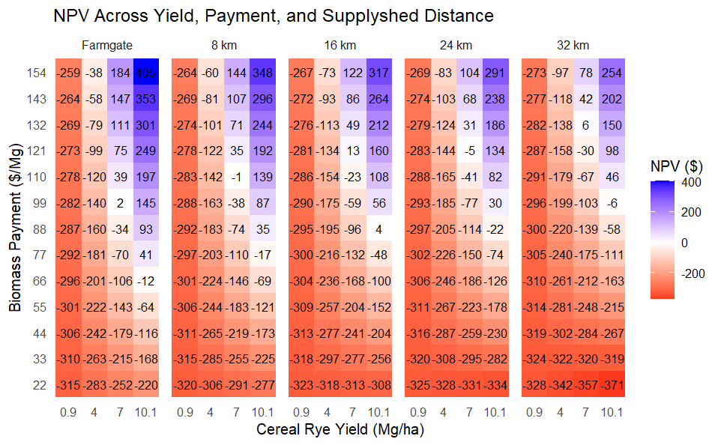
Table Sxx. Per hectare annualized net benefits of a bioenergy cereal rye biomass system selling to an anaerobic digester (AD) facility in Iowa, USA given yield and scenario dependent annualized production costs at a 6% discount rate. The farmgate scenario calculates net benefits of establishing, fertilizing, harvesting and selling cereal rye. The four radial supplyshed distances look at the net benefits of the AD system and includes trucking and loading/unloading costs. Prices are in 2026 USD.
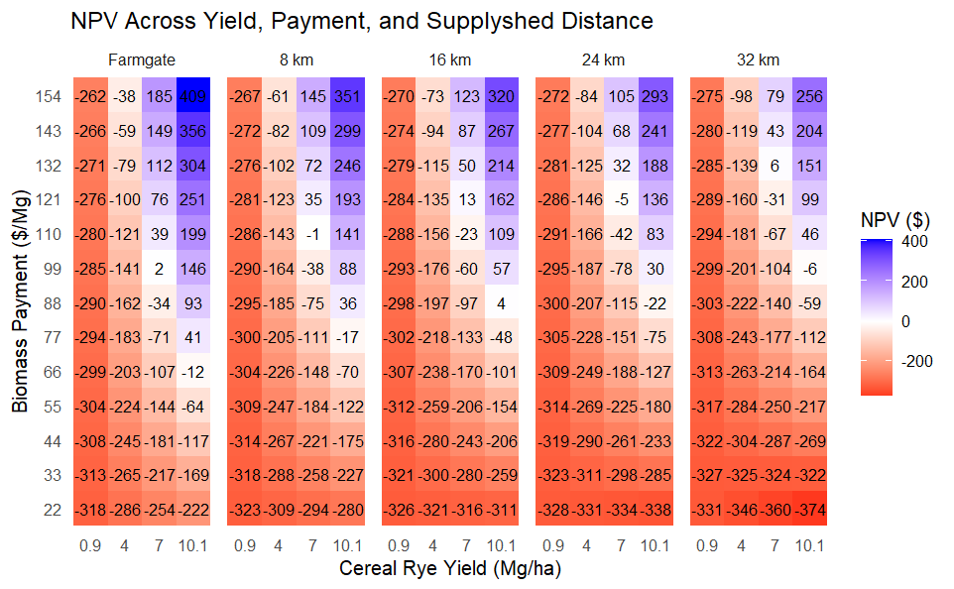
Table Sxx. Per hectare annualized net benefits of a bioenergy cereal rye biomass system selling to an anaerobic digester (AD) facility in Iowa, USA given yield and scenario dependent annualized production costs at a 7% discount rate. The farmgate scenario calculates net benefits of establishing, fertilizing, harvesting and selling cereal rye. The four radial supplyshed distances look at the net benefits of the AD system and includes trucking and loading/unloading costs. Prices are in 2026 USD.
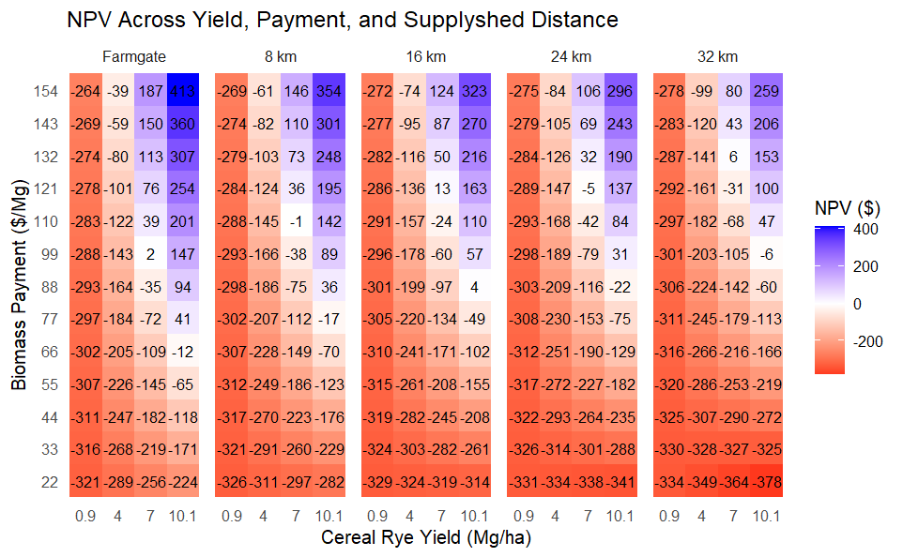
Table Sxx. Per hectare annualized net benefits of a bioenergy cereal rye biomass system selling to an anaerobic digester (AD) facility in Iowa, USA given yield and scenario dependent annualized production costs at an 8% discount rate. The farmgate scenario calculates net benefits of establishing, fertilizing, harvesting and selling cereal rye. The four radial supplyshed distances look at the net benefits of the AD system and includes trucking and loading/unloading costs. Prices are in 2026 USD.
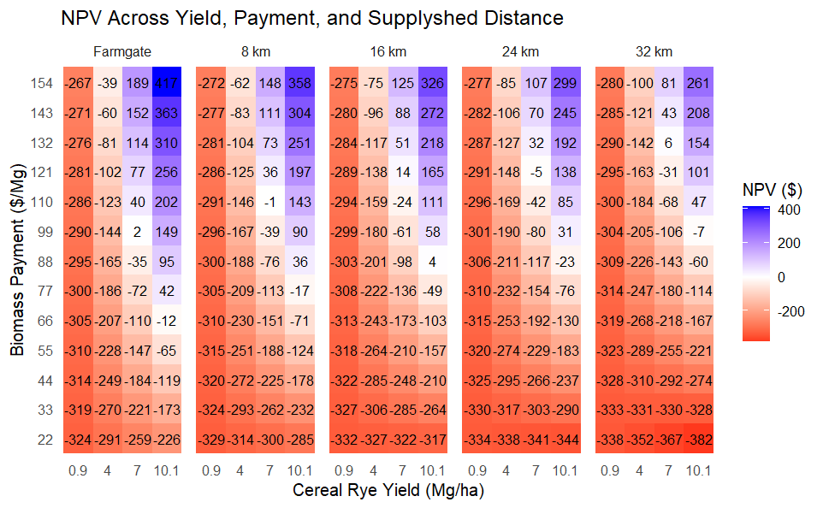
Table Sxx. Per hectare annualized net benefits of a bioenergy cereal rye biomass system selling to an anaerobic digester (AD) facility in Iowa, USA given yield and scenario dependent annualized production costs at a 9% discount rate. The farmgate scenario calculates net benefits of establishing, fertilizing, harvesting and selling cereal rye. The four radial supplyshed distances look at the net benefits of the AD system and includes trucking and loading/unloading costs. Prices are in 2026 USD.
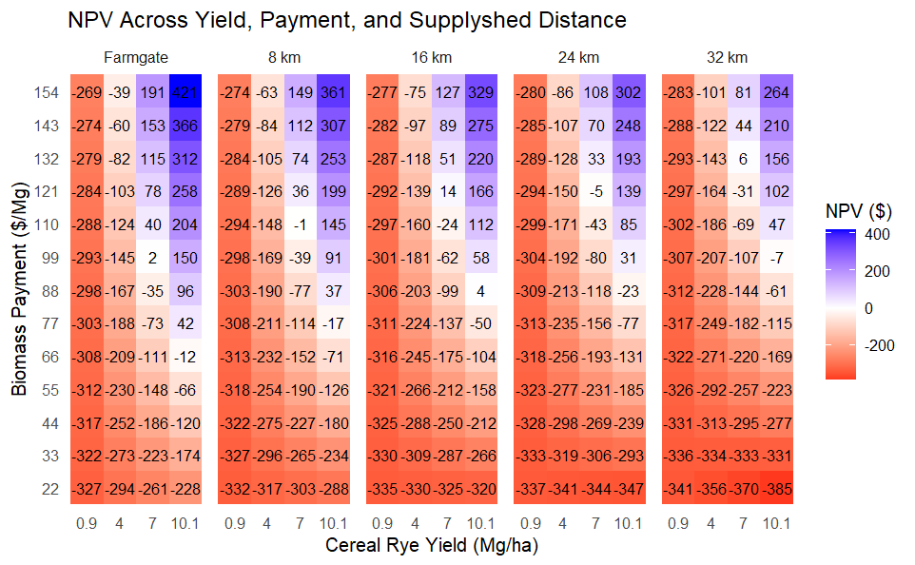
Table Sxx. Per hectare annualized net benefits of a bioenergy prairie biomass system selling to an anaerobic digester (AD) facility in Iowa, USA given yield and scenario dependent annualized production costs at a 5% discount rate. The top panel estimates net benefits when direct costs and opportunity costs are considered. The farmgate scenario calculates net benefits of establishing, fertilizing, harvesting and selling prairie. The four radial supplyshed distances look at the net benefits of the AD system and includes trucking and loading/unloading costs within each radial band. Prices are in 2026 USD.
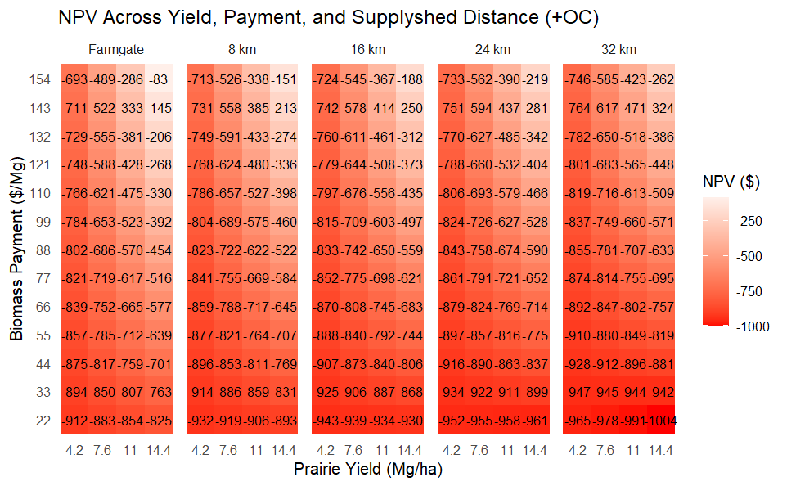
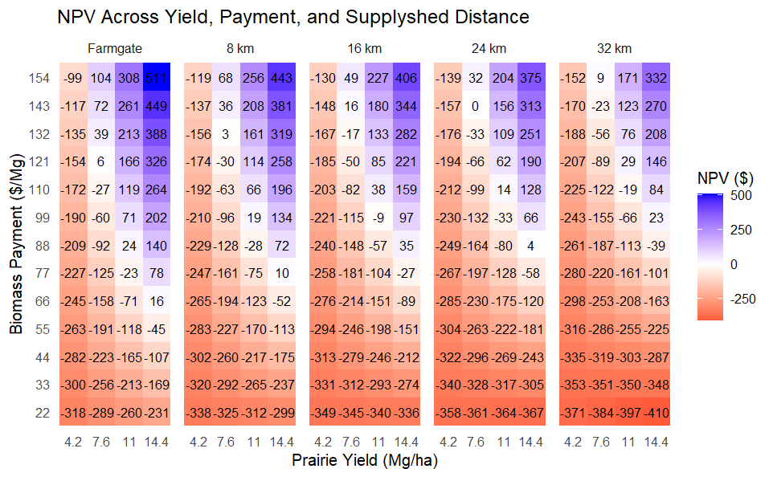

Table Sxx. Per hectare annualized net benefits of a bioenergy prairie biomass system selling to an anaerobic digester (AD) facility in Iowa, USA given yield and scenario dependent annualized production costs at a 6% discount rate. The top panel estimates net benefits when direct costs and opportunity costs are considered. The farmgate scenario calculates net benefits of establishing, fertilizing, harvesting and selling prairie. The four radial supplyshed distances look at the net benefits of the AD system and includes trucking and loading/unloading costs within each radial band. Prices are in 2026 USD.
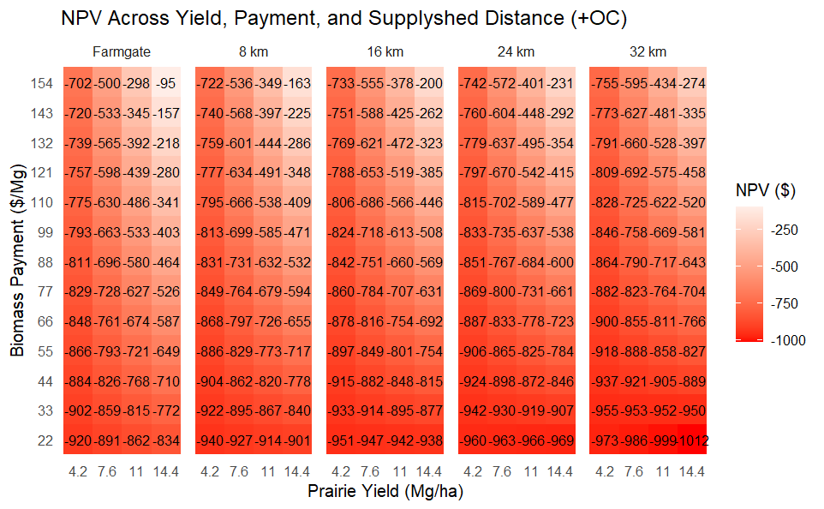
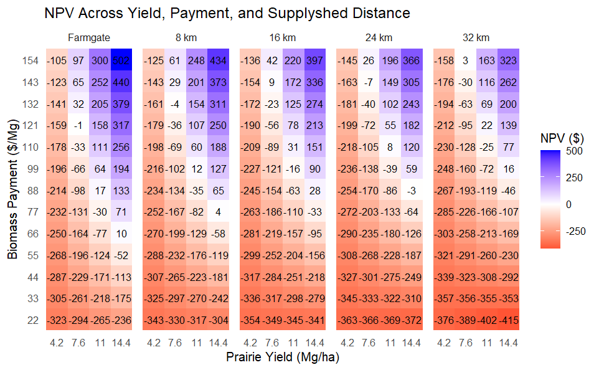

Table Sxx. Per hectare annualized net benefits of a bioenergy prairie biomass system selling to an anaerobic digester (AD) facility in Iowa, USA given yield and scenario dependent annualized production costs at a 7% discount rate. The top panel estimates net benefits when direct costs and opportunity costs are considered. The farmgate scenario calculates net benefits of establishing, fertilizing, harvesting and selling prairie. The four radial supplyshed distances look at the net benefits of the AD system and includes trucking and loading/unloading costs within each radial band. Prices are in 2026 USD.
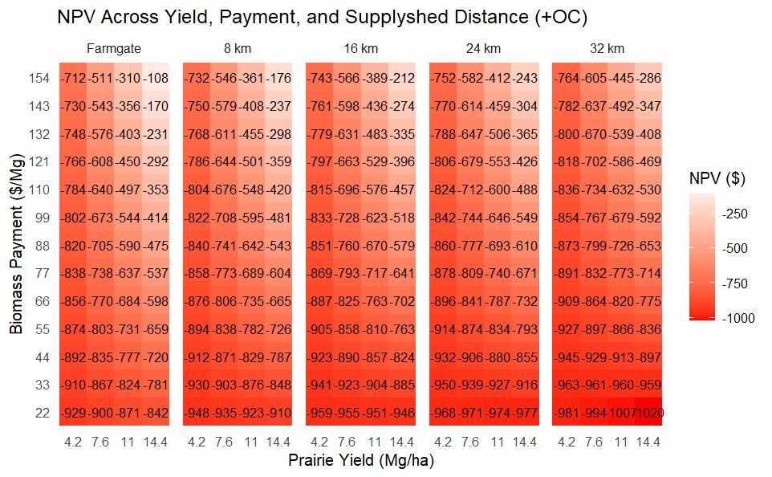
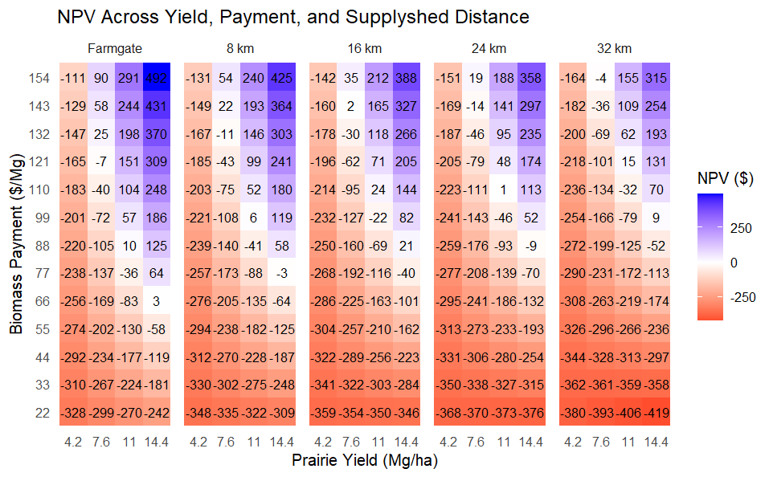

Table Sxx. Per hectare annualized net benefits of a bioenergy prairie biomass system selling to an anaerobic digester (AD) facility in Iowa, USA given yield and scenario dependent annualized production costs at a 8% discount rate. The top panel estimates net benefits when direct costs and opportunity costs are considered. The farmgate scenario calculates net benefits of establishing, fertilizing, harvesting and selling prairie. The four radial supplyshed distances look at the net benefits of the AD system and includes trucking and loading/unloading costs within each radial band. Prices are in 2026 USD.
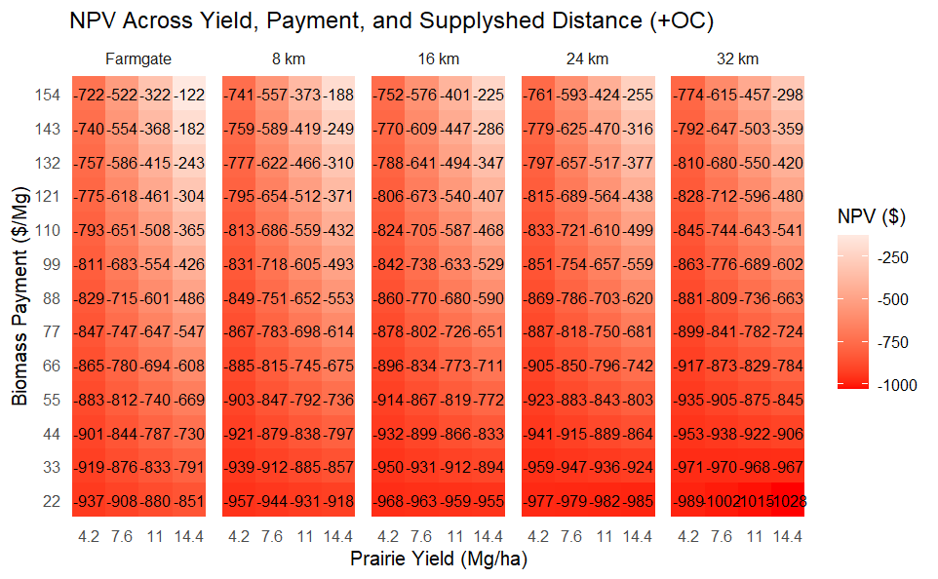
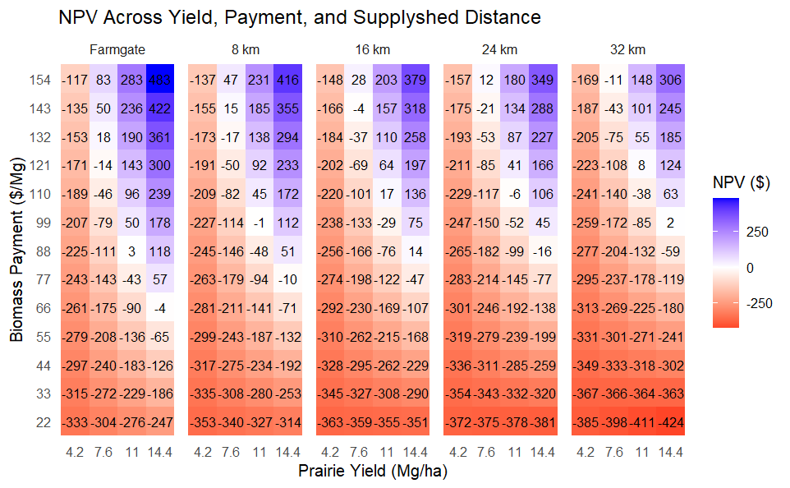

Table Sxx. Per hectare annualized net benefits of a bioenergy prairie biomass system selling to an anaerobic digester (AD) facility in Iowa, USA given yield and scenario dependent annualized production costs at a 9% discount rate. The top panel estimates net benefits when direct costs and opportunity costs are considered. The farmgate scenario calculates net benefits of establishing, fertilizing, harvesting and selling prairie. The four radial supplyshed distances look at the net benefits of the AD system and includes trucking and loading/unloading costs within each radial band. Prices are in 2026 USD.
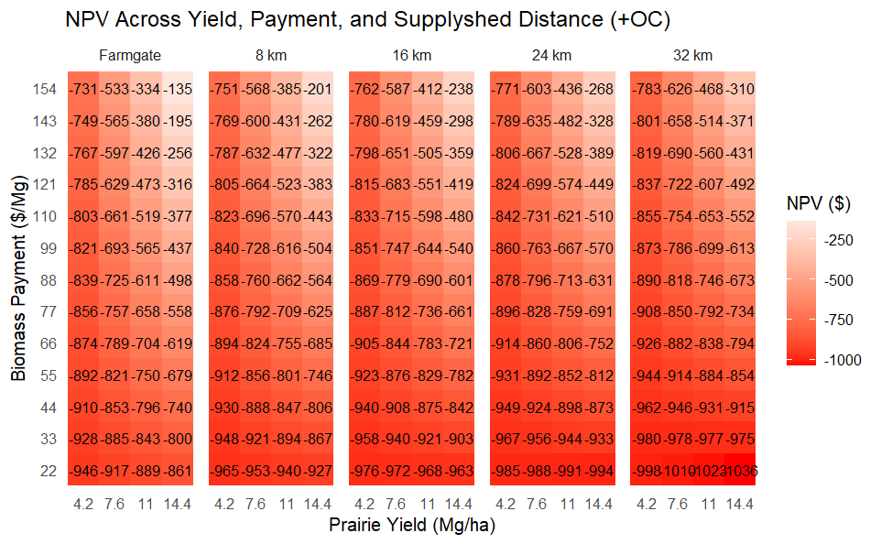
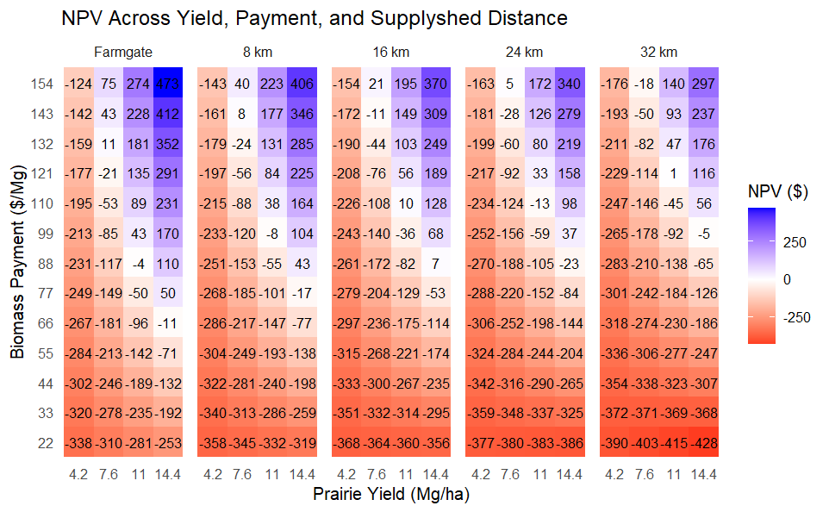

References
Akron Services, Inc. 2025. 2026 Pesticide Prices. Illinois.
Crespo, C., P.L. O’Brien, S.J. Ruis, J.L Kovar, and T.C. Kaspar. 2024. Thermal time and precipitation dictate cereal rye shoot biomass production. Field Crops Research, 315: 109473.
Bravard, E., D.E. James, E. Zimmerman, T. Bowman, and J.C. Tyndall. 2022. Financial analysis for the use with the Agricultural Conservation Planning Framework: Data for the State of Iowa. Distributed by the ACPF National Hub, Iowa Water Center, Iowa State University, Ames, Iowa.
Bravard, E., E. Zimmerman, J.C. Tyndall, and D. James. 2024. Welcome to the New Frontier: Introducing Extension To The Next Generation Of Conservation Planning Tools. Journal of Extension.
Brittingham, M.C. and J.A. DeCecco. 2024. Riparian Buffers For Wildlife. The Pennsylvania State University. https://extension.psu.edu/riparian-buffers-for-wildlife.
Dietzel, R., M.E. Jarchow, and M. Liebman. 2015. Above- and belowground growth, biomass, and nitrogen use in maize and reconstructed prairie cropping systems. Crop Ecology, Management, & Quality, 55(2): 910-923.
Edwards, W. 2020. Estimating Value of Corn Stover, File A3-10. Iowa State University, Ames, IA.
ESRI (Environmental Systems Research Institute). 2011. ArcGIS Desktop: Release 10. Redlands, CA: Environmental Systems Research Institute.
Feyerseisen, G.W., G.G.T. Camargo, R.E. Baxter, J.M. Baker, and T.L. Richard. 2013. Cellulosic Biofuel Potential of a Winter Rye Double Crop across the U.S. Corn–Soybean Belt. Agronomy Journal, 105(3): 631-642.
Fischer, R. and C. Fischenich. 2000. Design Recommendations for Riparian Corridors and Vegetated Buffer Strips, ERDC TN-EMRRP-SR-24. US Army Engineer Research and Development Center, Environmental Laboratory, Vicksburg, MS.
Frankenberger, J., I. Chaubey, E. Kladivko, and M. McCahon. 2009. Identification of Suitable Sites for Constructed Wetlands to Remove Nitrate: Final Report to the Indiana State Department of Agriculture.
Franklin, J.F. and D.B. Lindenmayer. 2009. Importance of matrix habitats in maintaining biological diversity. PNAS, 106(2): 349-350.
Garms, J., M. Lindquist, and K. Varland. 2009. Prairie vegetation and energy production harvest plan for WMAs. A report to the Minnesota Legislature, Environment and Natural Resource Committees. Minnesota Session Laws 2008, Chapter 179, Section 7. Subdivision 14.
Giddens, E., L. Jackson, and K. Enshayan. 2017. Linking nutrient reduction practices with biomass energy. Tallgrass Prairie Publications and Reports. 19. https://scholarworks.uni.edu/tpc_facpub/19
Gilbert-Norton, L., R. Wilson, J.R. Stevens, and K.H. Beard. 2010. A Meta-analytic review of corridor effectiveness. Conservation Biology, 24(3): 660-668.
Herbstritt, S., T.L. Richard, S.H. Lence, H. Wu, P.L. O’Brien, B.D. Emmett, T.C. Kaspar, D.L. Karlen, K. Kohler, and R.W. Malone. 2022. Rye as an energy cover crop: Management, forage quality and revenue opportunities for feed and bioenergy. Agriculture, 12(10): 1691.
Huddell, A.M., R. Thapa, G.S. Marcillo, L.J. Abendroth, V.J. Ackroyd, S.D. Armstrong, G. Asmita, et al. 2024. U.S. cereal rye winter cover crop growth database. Scientific data, 11(1): 200.
IDALS (Iowa Department of Agriculture and Land Stewardship), IDNR (Iowa Department of Natural Resources), and ISU CALS (Iowa State University College of Agriculture and Life Sciences). 2025. Iowa Nutrient Reduction Strategy: A science and technology-based framework to assess and reduce nutrients to Iowa waters and the Gulf of America.
Igos, E., K. Golkowska, D. Koster, B. Vercisch, and E. Benetto. 2016. Using rye as cover crop for bioenergy production: An environmental and economic assessment. Biomass and Bioenergy, 95: 116-123.
Jarchow, M.E., and Liebman, M. (2010). Incorporating prairies into multifunctional landscapes: Establishing and managing prairies for enhanced environmental quality, livestock grazing and hay production, bioenergy production, and carbon sequestration. University Extension PMR. 1007.
Johanns, A. 2026. Cash Rental Rates for Iowa 2026 Survey, File C2-10. Iowa State University, Ames, IA. https://www.extension.iastate.edu/agdm/wholefarm/pdf/c2-10.pdf
Johanns, A. and C. Hart. 2026. 2026 Iowa Farm Custom Rate Survey, File A3-10. Iowa State University, Ames, IA. Koehler-Cole, K., R.W. Elmore, H. Blanco-Canqui, C.A. Francis, C.A. Shapiro, C.A. Proctor, S.J. Ruis, S. Irmak, and D.M. Heeren. 2022. Cover crop planting practices determine their performance in the U.S. Corn Belt. Agronomy Journal, 115(2): 526-543.
Krueger, E.S., T.E. Ochsner, P.M. Porter, and J.M. Baker. 2011. Winter rye cover crop management influences on soil water, soil nitrate, and corn development. Soil Fertility and Crop Nutrition, 103(2): 316-323.
Lenhart, C, B. Gordon, J. Peterson, W. Eshenaur, L. Gifford, B. Wilson, J. Stamper, L. Krider, and N. Utt. 2017. Agricultural BMP Handbook for Minnesota, 2nd Edition. St. Paul, MN: Minnesota Department of Agriculture.
Lohani, S., C. Baffaut, A.L. Thompson, N. Aryal, R.L. Bingner, D.L. Bjorneberg, D.D. Bosch, et al. 2020. Performance Of The Soil Vulnerability Index With Respect To Slope, Digital Elevation Model Resolution, And Hydrologic Soil Group. Journal of Soil and Water Conservation, 75:1, 12-27, DOI: 10.2489/jswc.75.1.12
Lundvall, J. and J. Sawyer. 2019. Corn Yield Response to Tillage and Nitrogen Fertilizer Rate. Iowa State University Research and Demonstration Farms Progress Reports. 2018(1).
Malone, R.W., A. Radke, S. Herbstritt, H. Wu, Z. Qi, B.D. Emmett, M.J. Helmers, et al. 2023. Harvested winter rye energy cover crop: multiple benefits for North Central US, Environmental Research Letters, 18: 074009.
Nichols, V.A., F.E. Miguez, M.E. Jarchow, M.Z. Liebman, and B.S. Dien. 2014. Comparison of Cellulosic Ethanol Yields from Midwestern Maize and Reconstructed Tallgrass Prairie Systems Managed for Bioenergy, 7: 1550-1560.
Nietch, C.T., R.J. Hawley, A. Safwat, J.R. Christensen, M.T. Heberling, J. McManus, R. McClatchey, et al. 2024. Implementing constructed wetlands for nutrient reduction at watershed scale: Opportunity to link models and real-world execution. Journal of Soil and Water Conservation, 79(3): 113-131.
NRCS (Natural Resource Conservation Service). 2020. Iowa Native Prairie Planting Guide. Natural Resource Conservation Service, Des Moines, IA.
Porter, S.A., M.D. Tomer, D.E. James, J.D. Van Horn, and C.M.J. Sandoval-Green. 2025. Agricultural Conservation Planning Framework ArcGIS toolbox user’s manual version 7.0. Distributed by the ACPF National Hub, Iowa Water Center, Iowa State University, Ames, Iowa.
Resasco, J. 2019. Meta-analysis on a decade of testing corridor efficacy: What new have we learned? Current Landscape Ecology Reports, 4: 61-69.
Schulte, L.A., J. Niemi, M.J. Helmers, M. Liebman, J.G. Arbuckle, D.E. James, R. Kolka, et al. 2017. Prairie Strips Improve Biodiversity And The Delivery Of Multiple Ecosystem Services From Corn–Soybean Croplands. Proceedings of the National Academy of Sciences, 114(42), 11247-11252.
Swan, A., S.A. Williams, K. Brown, A. Chambers, J. Creque, J. Wick, and K. Paustian. 2020. COMET-Planner: Carbon and greenhouse gas evaluation for NRCS conservation practice planning.
Sawyer, J., E. Nafziger, G. Randall, L. Bundy, G. Rehm, and B. Joern. 2006. Concepts and rationale for regional nitrogen rate guidelines for corn. PM2015. Iowa State University, Extension, Ames, IA.
Sievers, B. May 2024. Personal Communication: Field Day at Sievers Farm.
Tetra Tech. 2019. Best Management Practice Modeling Scenarios For The Minnesota River Basin Sediment Strategy.
Tilman, D., P.B. Reich, and J.M.H. Knops. 2006. Biodiversity and ecosystem stability in a decade-long grassland experiment. Nature, 441: 629-632.
Tomer, M.D., S.A. Porter, D.E. James, K.M. Boomer, J.A. Kostel, and E. McLellan. 2013. Combining precision conservation technologies into a flexible framework to facilitate agricultural watershed planning. Journal of Soil and Water Conservation, 68(5), 113A-120A.
Tomer, M.D., S.A. Porter, K.M.B. Boomer, D.E. James, J.A. Kostel, M.J. Helmers, T.M. Isenhart, and E. McLellan. 2015a. Agricultural conservation planning framework: 1. Developing multipractice watershed planning scenarios and assessing nutrient reduction potential. Journal of Environmental Quality, 44(3), 754-767.
Tomer, M.D., K.MB. Boomer, S.A. Porter, B.K. Gelder, D.E. James, and E. McLellan. 2015b. Agricultural conservation planning framework: 2. Classification of riparian buffer design types with application to assess and map stream corridors. Journal of Environmental Quality, 44(3), 768-779.
Tomer, M.D., D.E. James, and C.M. Sandoval‐Green. 2017. Agricultural conservation planning framework: 3. Land use and field boundary database development and structure. Journal of Environmental Quality, 46(3), 676-686.
Tomer, M. D., S.A. Porter, D.E. James, and J.D. Van Horn. 2020. Riparian Catchments: A Landscape Approach To Link Uplands With Riparian Zones For Agricultural And Ecosystem Conservation. Journal of Soil and Water Conservation, 75(4), 94A-100A.
Tyndall, J. and G. Roesch. 2014. Agricultural Water Quality BMPs: A Standardized Approach to Financial Analysis. Journal of Extension, 52(3): Article 34.
USDA (United States Department of Agriculture). USDA AMS Livestock, Poultry & Grain Market News. 2026. Iowa Production Cost Report (Bi-Weekly) Agricultural Marketing Service Livestock, Poultry, and Grain Market News.
Zimmerman, E.K., J.C. Tyndall, and L.A. Schulte. 2019. Using spatially targeted conservation to evaluate nitrogen reduction and economic opportunities for best management practice placement in agricultural landscapes. Environmental Management, 64(3): 31.

